**HTTP Proxy Server Testing using Jmeter**

Here is the **roadmap** of this practical example

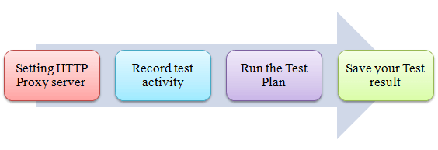

**Step 1) Setting HTTP Proxy server**

This is Step-by-step guide to setup proxy

1. Start **JMeter**
2. Select **Test Plan** on the tree
3. Add **Thread Group**

Right click on the Test Plan and add a new thread group: **Add** => **Threads (Users)** =>**Thread Group**

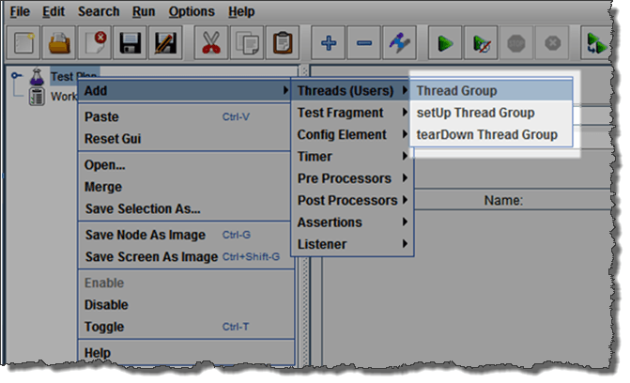

1. Add **HTTP Request**

Select the Thread Group; right click **Add** => **Config Element** => **HTTP Request Defaults**

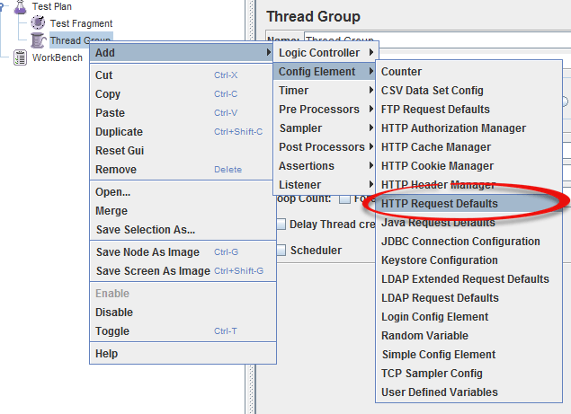

In new HTTP Request Defaults element: In Server name or IP, enter "google.com". You should keep the others fields blank

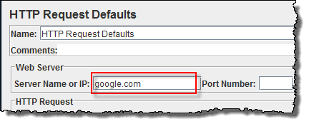

1. Add **Recording Controller**

Right click on the "Thread Group" and add a recording controller: **Add** => **Logic Controller** =>

**Recording Controller**

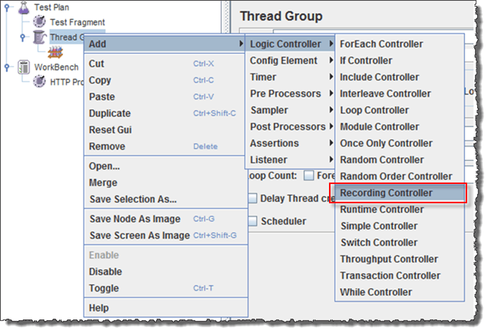

1. Add **Proxy Server** to WorkBench

Right click on the Workbench and add the http proxy: **Add** => **Non-Test Elements** => **HTTP Proxy Server**

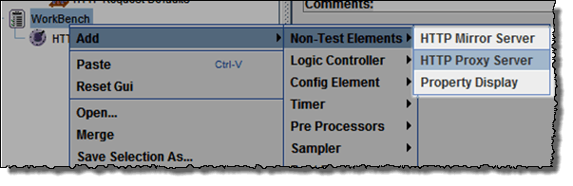

1. Set **Target Controller** where your recorded scripts will be added

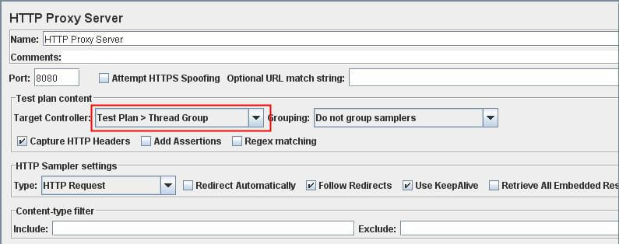

1. **Start** Proxy Server

Return to HTTP Proxy Server, and click the **Start** button at the bottom. Now your JMeter proxy server start

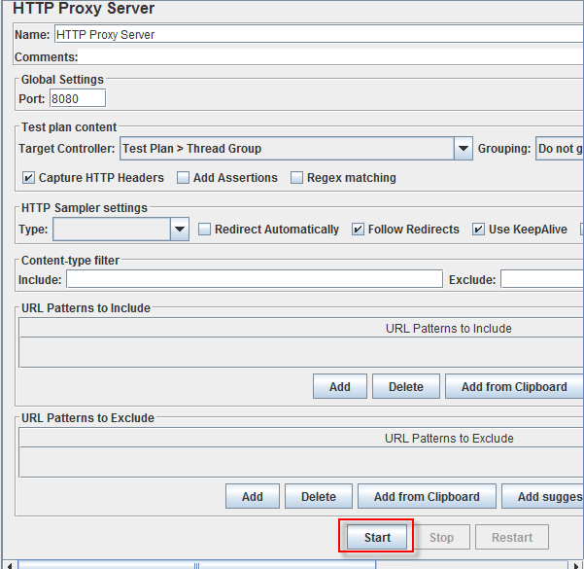

1. Start your Browser (I used Firefox), choose **Tool** => **Option** => **Advanced** => **Network** => **Setting** => Enter HTTP proxy as figure below

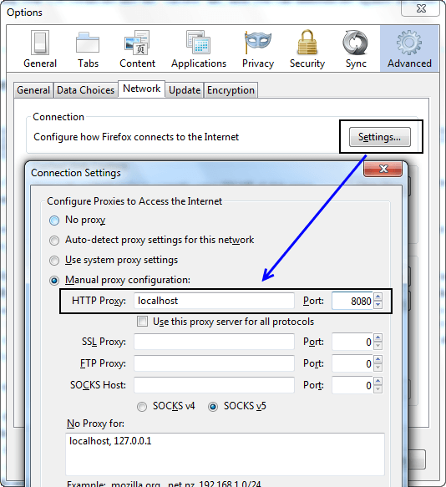

**Step 2) Record your activity**

1. Now Launch http://www.google.com in your web browser (JMeter still open)
2. Do activities search the keyword "**jmeter**".
3. Back to JMeter, in HTTP Proxy Server, click **Stop** when finished

1. After finishing recording, you will see JMeter automatically created a new HTTP request as figure below

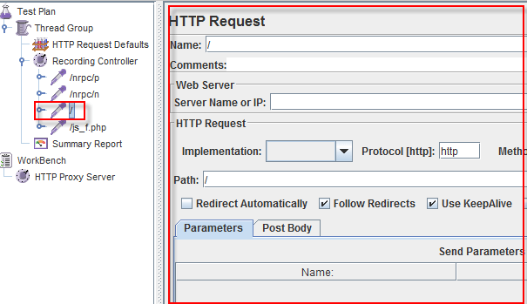

JMeter has already recorded a user request to **Home Page** of Google website. Http://www.google.com/

The other HTTP requests display in above figure, you should remove them. Because, sometime JMeter also records some advertising links while you are searching keyword on Google. We should ignore them in our Test Plan

1. Click File => Save your Test Plan as

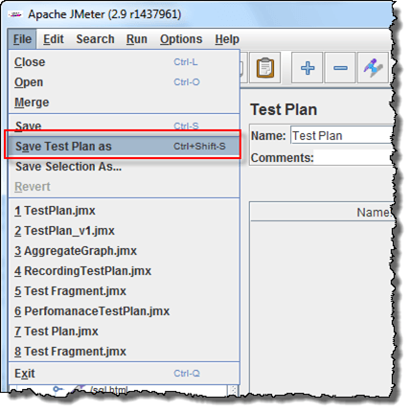

1. A Dialog box display => enter a name of your test plan at File Name field => Click Save

Now your Test Plan is saved under name RecordingTestPlan.jmx

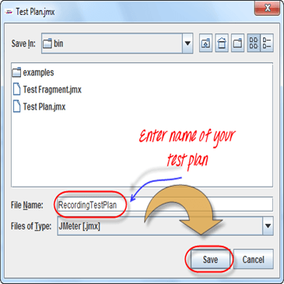

**Step 3) Run your Test Plan**

1. Select **Thread Group => Add => Listener=> Summary Report**

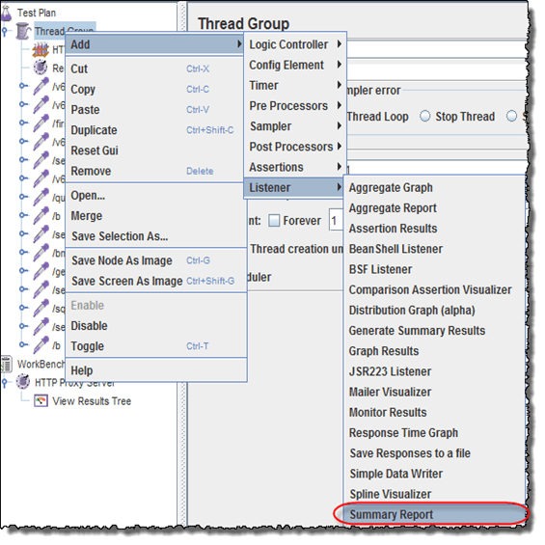

1. The Summary Report will show some basic statics

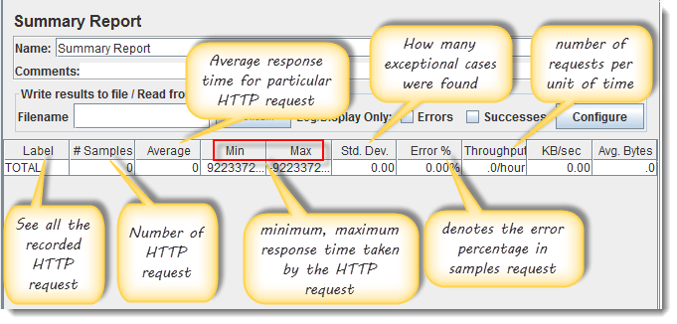

1. Select Thread Group, enter information as figure below

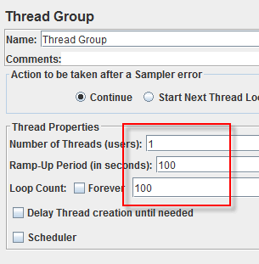

You can refer the article 5 JMeter Performance Testing.doc to know the detail about Thread Group configuring

1. Before you start the test, select "Summary Report". When you ready to run test, select Run => Start (Ctrl+R). JMeter will playback your activity in 100 times

As the test runs, the statistics will change until the test is done.

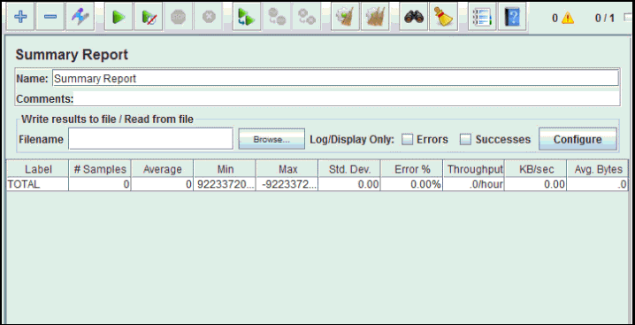

**Step 4) Save your test result**

1. Click **Save Table Data** to save test result to file

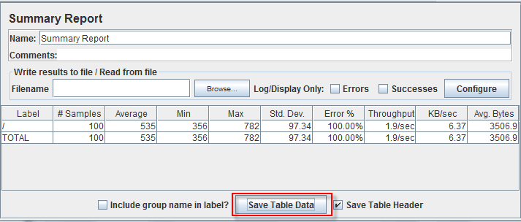

1. Enter the name of test result and click Save. Test Result in JMeter is saved in *.csv format as default

